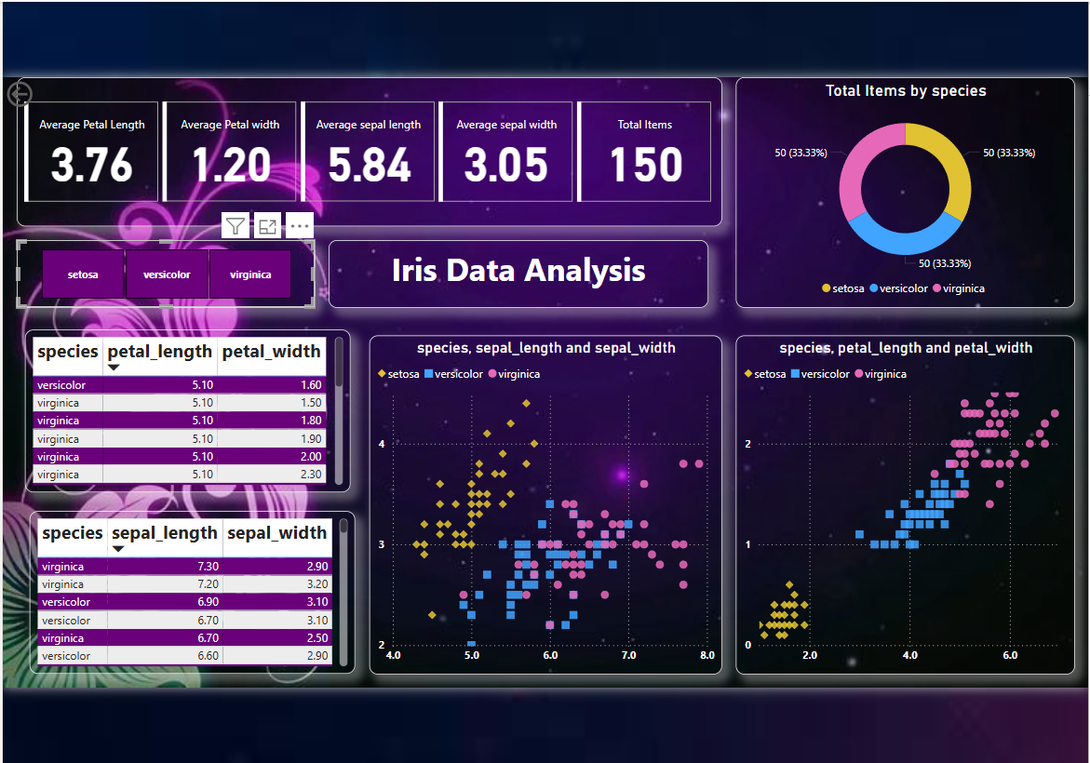

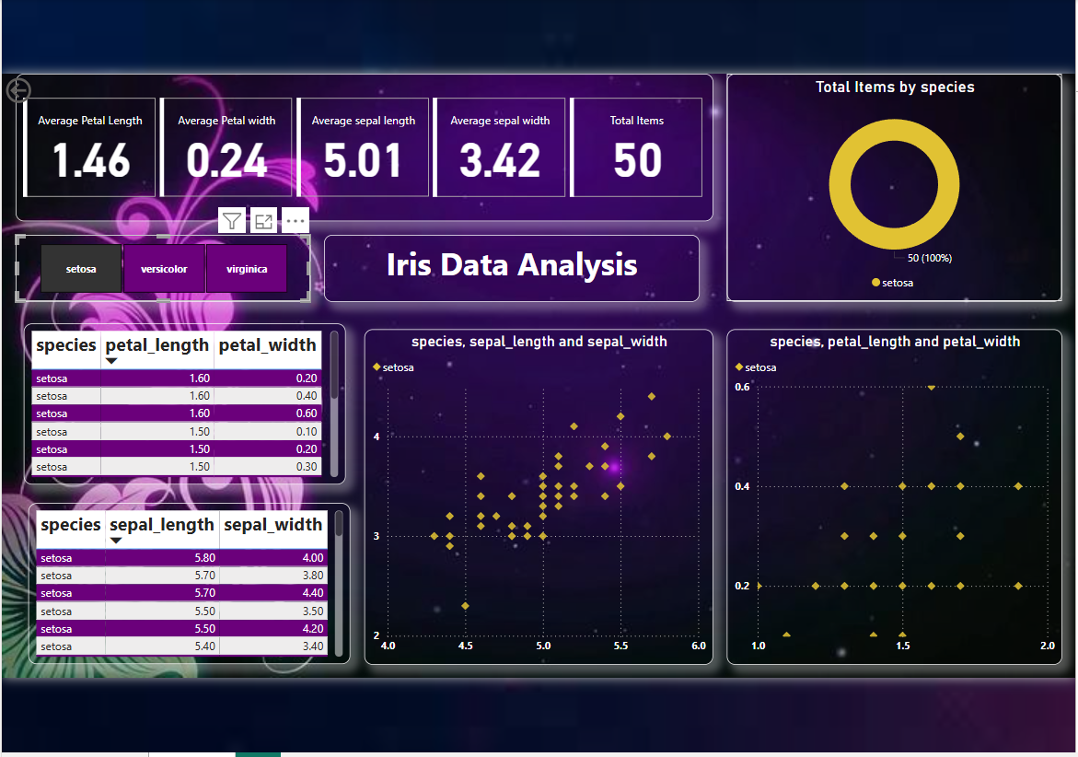

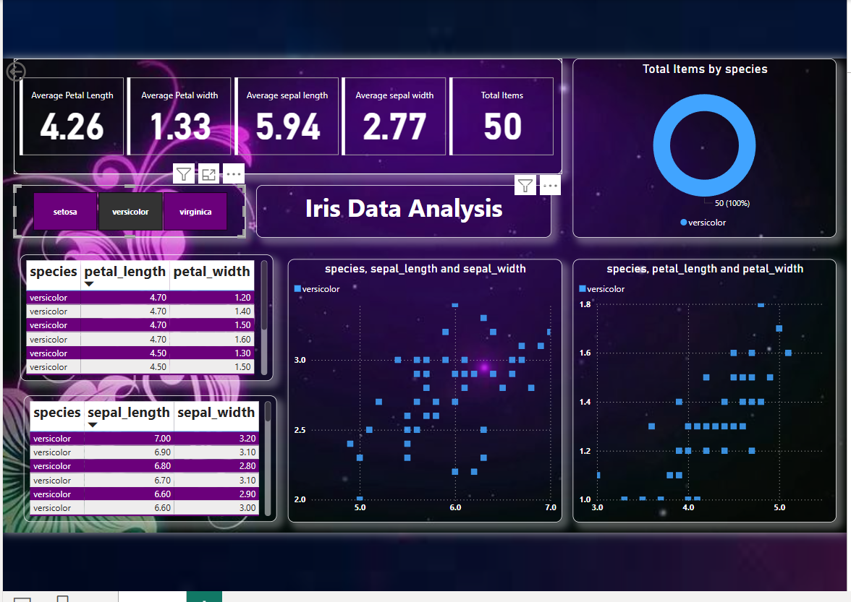

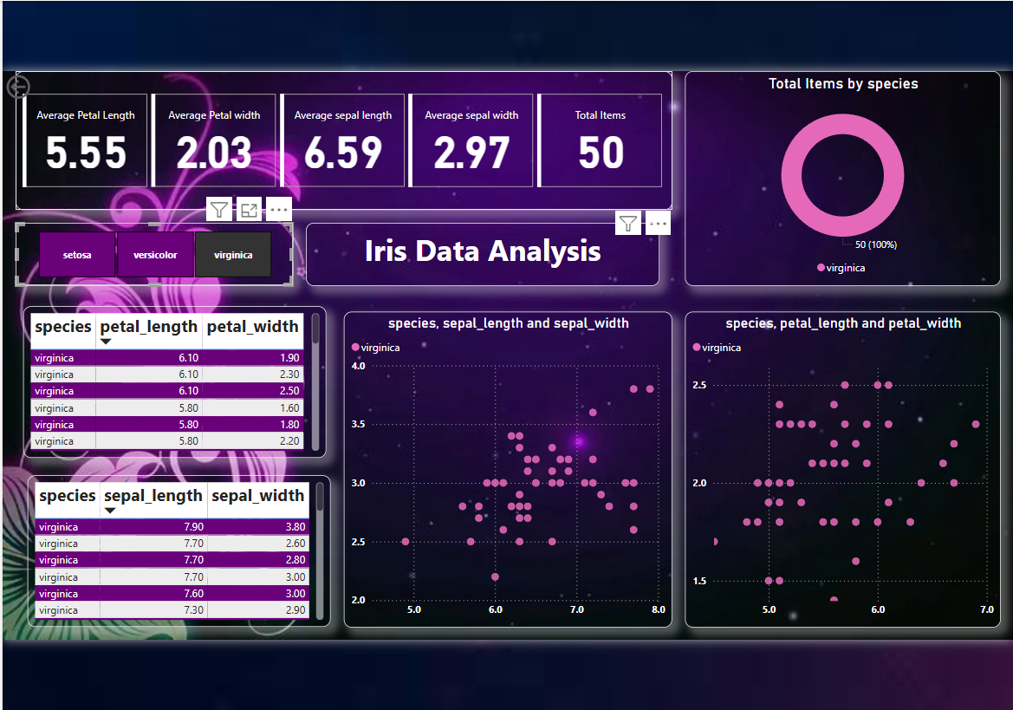

Here are 5 valuable insights based on the scatter plot analysis:

1. Setosa is distinct in both sepal and petal measurements: Setosa species are clearly separated from Versicolor and Virginica, indicating unique characteristics.

2. Petal measurements provide clearer species separation: Petal length and width show better separation between species compared to sepal measurements.

3. Versicolor and Virginica show overlap: While Versicolor and Virginica overlap in both sepal and petal measurements, Virginica tends to have larger petals.

4. Sepal width is notable for Setosa: Setosa has relatively high sepal width compared to sepal length.

5. Petal characteristics are key for species classification: The clear separation between species in petal measurements suggests these characteristics could be crucial for developing a classification model.

Unlocking Insights from Iris Data Analysis 🔓

I recently dove into the Iris dataset and uncovered some fascinating findings:

🌟 Key Insights:

- Setosa species are distinct in both sepal and petal measurements 🌿
- Petal length and width provide clearer separation between species compared to sepal measurements 💡
- Versicolor and Virginica show overlap, but Virginica tends to have larger petals 📈

📊 KPIs:

- Average length and width values of all species
- Total number of items: 150

📈 Visualizations:

- Scatter plots for sepal length vs. width and petal length vs. width, highlighting the differences between Setosa, Versicolor, and Virginica 📊
- * Top 3 length and width values for all species and individual species 🏆

🤝 Let's Discuss:

What do you think about these insights? Share your thoughts on data analysis and visualization in the comments below 💬. Let's connect and explore more data-driven insights together! 🤝

#DataAnalysis #DataVisualization #IrisDataset #MachineLearning #DataScience #Insights #LinkedInLearning #codveda #codvedatech #codvedainternship

